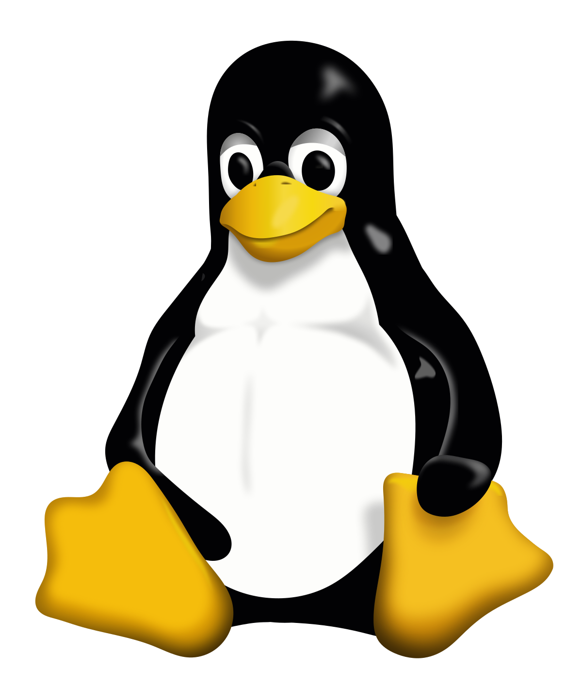LINUX

Linux is an operating system. Just like Windows or OS, it makes the communication between the software and the hardware for you. It is freedom. Linux is an open licensed system, which means it is completely developer friendly and you can distribute your modified version to help other users – use your powers for good my friend.

What is Linux Used For?

As well as an operating system, Linux has a few ‘think outside of the box’ uses.

* You can use it to troubleshoot other computers. Say for example your computer won’t boot up, you can still pop a live disc with Linux on, in the drive and access the hard drive.
* Build or host a website, in fact many of the websites you access run on Linux.
* An operating system for your computer.
* Creating servers at a cheaper cost.
* Linux is all around you – In your TV, Smart phone and even your fridge or washing machine. If it needs a programme, it needs the system to run it. Think of your washing machine as a tiny washing computer.
* Features:

Portable(Multiplatform)

Multitasking

Multi User

Multiprocessor (SMP) Support

Multithreading Support

Virtual Memory

Hierarchical File System

Graphical User Interface (X Window System, Wayland)

Wide Hardware Support

Dynamically Linked Shared Libraries as well as Static Libraries

POSIX Compliant (Almost)

Multiple Virtual Consoles

Multitple Filesystem Support

Multiple Networking Protocols (TCP/IP, IPX/SPX, Appletalk, AX.25)

Shell

Strong Security Model

Open Source

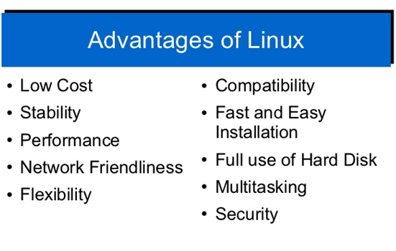

* Advantages of Linux:
* **Open Source Nature**
* Very open about it’s codes compared to other softwares
* A lot more secure compared to softwares like Windows
* Linux latest updates can work with almost any computer no matter how old whereas some softwares like Windows 10 require special requirements to be installed.
* Supports almost all major programming languages(Python, c++,java,etc)
* Customization of your linux computer is much better than Windows and offers multiple choices
* Linux is FREE!!!!!!!!!!!!!!!!!!!!!!
* Linux has more privacy options

The Cons of Linux

1. It isn’t as user friendly as Windows or as ‘straight out of the box.’
2. There isn’t a dedicated tech support, so getting ‘fixes’ for things is in your hands unless you want to subscribe to Enterprise Linux. However, you do get the software free so it’s something to consider.
3. If you are a gamer, you will prefer Windows as most of the games aren’t available but that’s not to say you can’t. Just not as much and as easy.
4. Drivers don’t really exist, there will be work around but users have reported problems when trying to use certain hardwares or old hardwares.
5. It’s probably better used as a dual boot rather than a Windows replacement due to the fact you can’t get proprietary programs on it and although they offer cousins, it won’t be the same. Photoshop is Photoshop, after all.

**SECURITY TOOLS AND SYSTEM TOOLS**

TeamViewer: It is a proprietary software in its version 12, that not only allows you to connect remotely, but also allows you to develop teamwork and transfer files.

**BACKUP TOOLS**

7zip: This open source alternative contains private add-ons such as unRAR (separate license). Large companies like IBM do not hesitate to use it and promote its use in both GNU / Linux and Windows.

* rsync: We want to stress rsync because it is actually an application related to the GNU environment. You can check the website<https://rsync.samba.org/>, but if you use Linux, it will be installed on your computer. Created by Andrew Tridgell, who is the father of Git and Samba Server, he developed these last two programs with the experience gained with rsync. We also need to stress that Git is very useful when manipulating and maintaining versions of system documentation and custom scripts stored, either on a Git server inside the company or an external server such as the famous GitHub. Rsync software will allow us to back up full directories by preserving the files (links, owners, prints) in a multiple and massive way through secure protocols like rsh and shh or even anonymously as public FTP!

Powershell: Its strength is “cmdlets” which are special commands that implement specific functions and emulate the use of “pipes” of Unix commands.

“curl”: allows you to quickly verify if a web service is running with the “-I -s” options, which receives the headers indicating the good health of the process.

**LINUX FILE SYSTEM:**

**Linux File System or any file system generally is a layer which is under the operating system that handles the positioning of your data on the storage, without it; the system cannot knows which file starts from where and ends where.**

**FILE SYSTEM TYPES:**

**Ext, Ext2, Ext3, Ext4, JFS, XFS, btrfs and swap**

**So what are these file systems that Linux offers?**

**Ext: old one and no longer used due to limitations.**

**Ext2: first Linux file system that allows 2 terabytes of data allowed.**

**Ext3: came from Ext2, but with upgrades and backward compatibility.**

**The only problem about it that the servers don’t use this kind of file system because this file system doesn’t support file recovery or disk snapshots.**

**Ext4: faster and allow large files with significant speed.**

**You may notice From the comparison above that Ext4 is the best Linux File System**

**ENTERTAINMENT AND MEDIA SOFTWARE:**

1. Kodi – Home Theater Software

[**Kodi**](https://kodi.tv/) **(previously known as XBMC) is a free and open source, highly customizable media server software.**

**Features of kodi:**

* **Runs on a wide variety of devices.**
* **It is user friendly.**
* **Supports a web interface.**
* **Supports a variety of user created Add-ons.**
* **Supports televisions and remote controls.**
* **Has a highly configurable interface via skins.**
* **Allows you to watch and record live TV.**
* **Supports importing pictures into a library.**
* **Allows you to browse, view, sort, filter or even start a slideshow of your pictures and much more.**

2. PLEX – Media Server

[**Plex**](https://www.plex.tv/) **is a powerful, secure and fully-featured and easy-to-install media server software.**

**Features:**

* **Supports encrypted connections with multiple user accounts.**
* **Allows you to easily pick and choose what to share.**
* **Offers a parental control functionality.**
* **Supports mobile sync which offers offline access to your media files.**
* **Supports flinging of video from one device to another.**
* **Also supports cloud sync.**
* **Supports audio fingerprinting and automatic photo-tagging.**
* **Has a media optimizer and much more.**

3. Madsonic – Music Streamer

[**Madsonic**](http://beta.madsonic.org/pages/index.jsp) **is an open source, flexible and secure web-based media server and media streamer developed using Java**

**features:**

* **Easy to use and comes with jukebox functionality.**
* **It is highly flexible and scalable with an intuitive web interface.**
* **Offers search and index functionalities with Chromecast support.**
* **Has built-in support for your dreambox receiver.**
* **Supports authentication in LDAP and Active Directory.**

User accounts:

Linux is multi-user system. This means more than one person can use the Linux. In order to gain access to the system and its resources, users are required to log in. By controlling access to system, you can prevent unauthorized users from using system as well as control access to data.

**Productivity Software and Application Software:**

1. LibreOffice
2. WizNote
3. Chrome
4. Firefox
5. Gimp
6. DropBox
7. Atom
8. WINE
9. Skype
10. RecordMyDesktop

## Productivity Tools

* [Boostnote](http://boostnote.io/) — My main note taking application. I use it mostly to store code snippets and reference material for my development activities. Its open source, cross platform and works completely offline. I wish to have an easier way to sync between multiple machines but since the notes are stored as CSON files, I am using a private Git repo to sync.
* [Simplenote](https://simplenote.com/) — I use Simplenote as my “scratchpad”, for quick notes and thoughts. mostly when on my mobile.
* [Cerebro](http://cerebroapp.com/) — Cerebro is an open source cross platform launcher similar to Spotlight and Alfred for Mac. The maintenance is kinda low atm and I felt the need to fork it, but it works pretty well. It doesnt have the same amount of plugins as Alfred does, but I have been developing some.

**Software security and updates:**

**1. [ClamAV](http://www.clamav.net/lang/en/)**

My favorite antivirus software for Linux is Sourcefire's ClamAV, a free, [open source](http://www.pcworld.com/businesscenter/article/209891/10_reasons_open_source_is_good_for_business.html) package designed to detect Trojans, viruses, malware and other malicious threats. Included in the software, which now comes preinstalled in several [Linux distributions](http://www.pcworld.com/businesscenter/article/204767/a_guide_to_todays_top_10_linux_distributions.html), are a multithreaded scanning daemon, command line utilities for on-demand file scanning, and an intelligent tool for automatic signature updates.

**3. [Wireshark](http://www.wireshark.org/)**

Wireshark is a network protocol analyzer that lets you capture and interactively browse the traffic running on a computer network.

**6. [Chkrootkit](http://www.chkrootkit.org/)**

Chkrootkit is a free tool designed to check locally for signs of a rootkit infection on your Linux machine.

**7. [Nessus](http://www.nessus.org/products/nessus)**

With more than five million downloads to date, Nessus is one of the most popular vulnerability scanners in the world, its makers say. The proprietary software features high-speed discovery, configuration auditing, asset profiling, sensitive data discovery and vulnerability analysis of your security posture. Personal use of Nessus is free, but enterprises must purchase a subscription costing $1,200 per year per Nessus scanner

## Graphics and Multimedia

* [Pinta](https://pinta-project.com/pintaproject/pinta/) — Pinta is a free, open source program for drawing and image editing. Its my image editor of choice. While Gimp is the most popular image editor on Linux, I found Pinta to much more simpler to use and resembles more with Photostop.
* [XnConvert](https://www.xnview.com/en/xnconvert/) — a powerful and free cross-platform batch image processor, allowing you to combine over 80 actions.
* [Draw.io](https://github.com/jgraph/drawio-desktop) — Draw.io is my app of choice for designing all kinds of diagrams, from flowcharts, to sequence diagrams or even wireframes. Its 100% free to use and can be integrated with Google Drive.

## Sound and Video

* [VLC](https://www.videolan.org/vlc/index.html) — my favorite media player. Version 3 have chromecast support built in which is even better.
* [Kdenlive](https://kdenlive.org/) — for video editing
* [Kazam](https://github.com/sconts/kazam) — To record screencasts
* [Spotify](https://www.spotify.com/pt/) — For listening to my favorite music.

## System utilities

* [Bleachbit](https://www.bleachbit.org/) — System cleaner utility.
* [Stacer](https://github.com/oguzhaninan/Stacer) — Linux System Optimizer and Monitoring
* [Caffeine](https://launchpad.net/caffeine) — To keep my machine awake
* [Pullover](https://github.com/cgrossde/Pullover) — To receive [Pushover](https://pushover.net/) notifications on my desktop
* [CopyQ](https://github.com/hluk/CopyQ) — To manage my clipboard

**Most info you will find at :** [**https://dev.to/brpaz/my-linux-development-environment-of-2018-ch7**](https://dev.to/brpaz/my-linux-development-environment-of-2018-ch7)

**Cites used:**

<https://greengarageblog.org/15-pros-and-cons-of-linux>

<https://www.quora.com/What-are-the-some-features-of-linux>

<https://itsfoss.com/linux-better-than-windows/>

<https://blog.pandorafms.org/linux-tools/>

<https://likegeeks.com/linux-file-system/>

<https://www.tecmint.com/best-media-server-software-for-linux/>

<https://www.cyberciti.biz/faq/linux-what-defines-a-user-account/>

<http://www.linuxandubuntu.com/home/50-essential-linux-applications>

<https://www.pcworld.com/article/224955/7_free_security_tools_for_linux.html>

<https://dev.to/brpaz/my-linux-development-environment-of-2018-ch7>